**HD in Computing & Software Engineering**

***CSE5015 Computing Project Proposal Approval Sheet***

*Student Use only;*

|  |  |  |  |
| --- | --- | --- | --- |
| Group Name | Eventz | Attempt No | one |
| Title of the project |  | | |
| System platform | Web Application Desktop App  Mobile Application | | |
| Technology |  | | |
| Programming methodology | Structured System Analysis and Design Methodology  Object Oriented Analysis and Design Methodology | | |
| SDLC | Agile | | |

|  |  |  |  |
| --- | --- | --- | --- |
| Student No | GM/HDCSE/CMU/04/03 | Full Name | Kanishka Pasindu Mudithananda |
| Roles & Responsibilities; Project Manager –  A Project Manager is vital for project success, overseeing teams, resources, and project objectives. Proficient in communication, risk management, and problem-solving, they ensure projects meet constraints. Prioritizing quality, timelines, and thorough documentation, Project Managers navigate challenges, significantly contributing to successful project outcomes | | | |
| Student No | GM/HDCSE/CMU/04/07 | **Full Name** | Lahiru Lakshan A. L. |
| Roles & Responsibilities; Ui Engineer –  A UI (User Interface) Engineer is responsible for designing and implementing the visual elements and interactive features of a website or application. They collaborate closely with UX (User Experience) designers to create seamless and visually appealing interfaces. | | | |
| Student No | GM/HDCSE/CMU/04/20 | **Full Name** | E G Jenaro Perera |
| Roles & Responsibilities; System Analyst –  A Systems Analyst plays a key role in bridging the gap between business needs and technological solutions within an organization. They analyze and understand the requirements of a system or project, working closely with stakeholders to gather and document specifications. Systems Analysts evaluate existing systems, identify areas for improvement, and propose effective solutions. | | | |
| Student No | GM/HDCSE/CMU/04/23 | **Full Name** | Dasun Madawa |
| Roles & Responsibilities; Software Engineer –  A Software Engineer is responsible for designing, developing, and maintaining software applications or systems. They analyze user needs, design software solutions, write and test code, and collaborate with cross-functional teams to ensure the successful implementation of projects. Software Engineers are proficient in programming languages and frameworks, and they leverage their technical expertise to solve complex problems and optimize software performance. | | | |
| Student No | GM/HDCSE/CMU/04/11 | **Full Name** | Bhanuka Madumal |
| Roles & Responsibilities; Software Engineer –  A Software Engineer is responsible for designing, developing, and maintaining software applications or systems. They analyze user needs, design software solutions, write and test code, and collaborate with cross-functional teams to ensure the successful implementation of projects. Software Engineers are proficient in programming languages and frameworks, and they leverage their technical expertise to solve complex problems and optimize software performance. | | | |
| Student No | GM/HDCSE/CMU/ |Full Name | Full Name | D W K G K N Weerasinghe | | | |
| Roles & Responsibilities; Software Engineer –  A Software Engineer is responsible for designing, developing, and maintaining software applications or systems. They analyze user needs, design software solutions, write and test code, and collaborate with cross-functional teams to ensure the successful implementation of projects. Software Engineers are proficient in programming languages and frameworks, and they leverage their technical expertise to solve complex problems and optimize software performance. | | | |

**System Functionality:**

|  |  |
| --- | --- |
| **Function (Admin)** | **Description** |
| View Advertisement | Admin can View Vendors advertisement |
| Delete Advertistment | Only Admin can perform this function |
| Update Advertistment | Admin can update advertisements |
| Payment Control | Admin can handle the payment request |
| Admin Registration | Admin who are in our platform to create an account |

|  |  |
| --- | --- |
| **Function (User)** | **Description** |
| Registration | Users who join to our “EventZ” platform to create an account |
| Login | When the user creates an account. then he can log in to the system |
| Search Events and Catergory filtering | If the users use this. he will be able to Find the events quickly |
| profile Customization | We empower our users to tailor their profiles by enabling them to upload a personal picture, provide a brief self-description, and update their password. |
| Feedback | Users can Send feedbacks to Vendors |
| Contact Us | Users have the capability to submit any issues or problems to the administrator through our platform. |
| Payment Option | User Can pay the money to vendors. when events were successfully done |

|  |  |
| --- | --- |
| **Function (Vendor)** | **Description** |
| Registration | Vendors who join to our “EventZ” platform to create an account |
| Login | When the Vendors create an account. then he can log in to the system |
| Search Events and Category filtering | If the Vendors use this. he will be able to Find the events quickly |
| profile Customization | We empower our Vendors to tailor their profiles by enabling them to upload a personal picture, provide a brief self-description, and update their password. |
| Contact Us | Users have the capability to submit any issues or problems to the administrator through our platform. |
| Add Advertisement | Only Vendors can use this function to add advertisements. |
| update Advertisement | also Vendors can update advertisements. |
| Delete Advertisement | also Vendors can delete advertisements. |

***Official use only***;

**Status:** **Approved / Rejected**

**Date of the status:** ………………………………

**Approved by:**

………………………… ………………………… …………………………

………………………… ………………………… …………………………

Title

Acknowledgement

**Table of Content**

Contents

2. Introduction x

3. Background study xii

4. Problem Statement / Description to the problem xiv

Objectives xx

5. Literature review xxi

6. Proposed Solution xxix

xxxiii

7. Justification to the solution xxxiii

8. Scope of the System xxxvii

9. Methodology & Technology xlii

Technology xlv

10. Gantt chart l

Risks li

Table of Figures

Table of Table

## Introduction

In today's rapidly evolving technological landscape, various innovations such as Full Stack Development, Edge Computing, Cybersecurity, Block chain, and Artificial Intelligence (AI) have become integral to our daily lives. Notably, Artificial Intelligence (AI) and cybersecurity are ubiquitous, permeating every industry and sector. AI facilitates enhanced performance and efficiency, often eliminating the need for extensive human intervention. Concurrently, Edge Computing emerges as a cutting-edge solution in the software domain, prioritizing data processing speed and reliability by leveraging computations closer to data sources.

Tailored specifically for event planning, this website fills a significant gap in the Sri Lankan market, offering unparalleled efficiency and convenience to customers. Recognizing the growing demand for streamlined event coordination and management, the platform aims to revolutionize the industry by providing a comprehensive solution that caters to diverse event needs. Leveraging innovative technology and local expertise, the platform facilitates seamless planning, booking, and execution processes, ensuring memorable and successful events. By integrating user-friendly interfaces, customizable options, and a wide range of service providers, it aspires to set a new standard for event planning in Sri Lanka, fostering collaboration, creativity, and customer satisfaction.

Recognizing the digital shift and the growing demand for convenience, "EventZ" introduces an innovative online platform tailored for seamless event planning. This platform transcends conventional event management paradigms by offering customers a comprehensive suite of services at their fingertips. Whether seeking professional photographers, dynamic DJs, state-of-the-art sound systems, elegant tents and huts, or captivating party lights and furnishings, "EventZ" becomes the one-stop destination.

Moreover, "EventZ" extends an invitation to budding entrepreneurs and professionals. Embracing the spirit of inclusivity, this platform empowers individuals to showcase their expertise and services, thereby fostering a vibrant community of event planners and enthusiasts. By amalgamating technology with personalized experiences, "EventZ" aspires to redefine event planning, ensuring memorable moments tailored to unique preferences and aspirations.

In essence, as navigating the intricacies of modern life, platforms like "EventZ" epitomize innovation and adaptability, catering to evolving consumer preferences while championing collaboration and creativity in the realm of event planning.

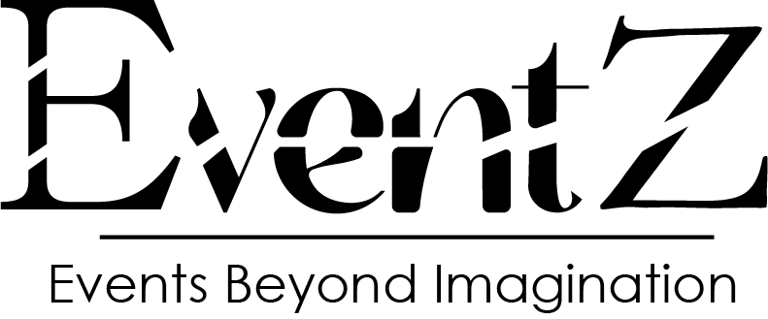

### Background study

**What is an event planning website?** An event planning website is an online platform designed to facilitate and streamline the process of organizing, coordinating, and managing various types of events. These websites typically offer tools, resources, and services such as vendor listings, venue booking, budgeting, scheduling, and communication tools to help individuals, businesses, or organizations plan and execute successful events efficiently.

Around the world, there are many websites that help people plan different types of events, like parties, corporate functions, and weddings. Some popular ones include Luxe Event Production, Adornment Events, Event Cracker and Blue wings event planner. In Sri Lanka, however, there's a website called 3nEvents, but it mainly focuses on planning weddings.

In Sri Lanka, there's no single website that helps people plan events easily. Right now, if someone wants to organize a party or any event, they must search on different places like Facebook to find a DJ, sound system, tents, or lights. This process is complicated and takes a lot of time because everything is scattered across various platforms.

The goal is to develop a new website addressing the complexities of event planning. This platform aims to serve as a comprehensive hub where users in Sri Lanka can effortlessly access a range of services essential for events, such as DJs, sound equipment, and decorations. By consolidating these offerings into a single platform, individuals no longer need to navigate multiple resources or rely on various social media platforms.

The primary objective is to streamline the event planning experience for users in Sri Lanka, enabling them to easily discover services, evaluate options, and secure bookings seamlessly. This initiative seeks to enhance efficiency, minimize complexities, and facilitate a more organized interaction among event planners, service providers, and customers. Ultimately, the platform aims to transform the event planning landscape, fostering convenience, transparency, and collaboration within the industry.

The idea is that there's a gap in the market. Right now, people have to use different methods to plan various events because there isn't a single platform in Sri Lanka that covers everything. Creating a new website that helps plan all kinds of events could make things easier for people and fill this gap in the market.

Luxe Event Production is known for helping with weddings. But this website goes further than that; it helps with all sorts of events, like birthday parties or business gatherings. On this site, you can easily find and hire DJs, musicians, photographers, and other services you might need for your event. It's like a one-stop-shop to make planning any event easier and more convenient.

## Problem Statement / Description to the problem

In the Sri Lankan event planning landscape, a critical void emerges, primarily due to the absence of a holistic, user-friendly platform that accommodates a wide array of event requirements. While existing platforms such as Luxe Event Production and 3nEvents have carved niches for themselves, their focus remains predominantly on specific event types, predominantly weddings. This limited scope fails to address the diverse and evolving needs of consumers who seek seamless, efficient, and comprehensive solutions for organizing various events, including but not limited to birthday parties, corporate functions, cultural celebrations, and social gatherings.

This existing system is not providing secure registration and profile management of all the users properly. This system is not providing on-line Help. This system doesn’t provide tracking of user’s activities and their progress. This manual system gives us very less security for saving data and some data may be lost due to miss management. This system is not providing event management through internet. This system is not providing proper events information. The system is giving manual information through the event management execute. (Santhosh, n.d.)

The current system lacks secure user registration and profile management. Additionally, it doesn't offer online assistance or track user activities and progress effectively. The manual approach compromises data security and can lead to information loss due to mismanagement. Furthermore, the system falls short in providing online event management and accurate event information, relying instead on manual methods that are less efficient and comprehensive.

Why would applying this idea to the project be beneficial? The idea is categorized into four distinct areas, each described below,

* **Operational Fragmentation**

The way things currently work makes people use different websites, companies, and services from many different places, like Facebook. This makes everything confusing and not very organized. It's like having to go to different stores to buy different parts of what you need for an event. Because of this, things become complicated, not very efficient, and it's hard to keep everything in order. For example, the prices might be different on different platforms, the way they do things might not be the same, and it's difficult to communicate because there isn't one clear way of doing things. So, this way of operating creates a lot of problems and makes things more difficult for people trying to plan events.

* **Streamlining Payment Processes with an Integrated Online Payment Portal**

In the current setup of the existing website, users face a cumbersome process when it comes to making payments. Instead of having a seamless and integrated system on the platform, users are redirected to separate communication channels such as Gmail or phone numbers to facilitate their payments. This disjointed approach not only complicates the user experience but also introduces potential inefficiencies, security concerns, and logistical challenges.

To address this significant drawback and enhance user convenience, the proposed solution involves integrating an online payment portal directly within our website. By incorporating a secure and user-friendly payment gateway, users can complete their transactions seamlessly, eliminating the need for external communication channels and ensuring a more streamlined and efficient payment process. This enhancement not only improves user satisfaction and trust but also enhances operational efficiency, security, and transparency, positioning the platform as a reliable and user-centric solution in the event planning landscape.

* **Limited Customization and Flexibility**

The existing platforms' inherent limitations curtail users' autonomy, creativity, and flexibility in crafting personalized event experiences tailored to their unique preferences, themes, cultural nuances, and budgetary constraints. This constraint stifles innovation, inhibits customization, and diminishes the potential for creating memorable, resonant, and authentic event experiences that reflect individuals' or organizations' distinct identities and aspirations.

* **Enhancing Transparency and Personalization through Detailed Service Provider Profiles**

Many existing event planning websites present services as monolithic packages, often providing only generic names or titles such as "DJ" or "Photographer" without offering any detailed profiles or insights into the individuals or companies offering these services. This lack of transparency and personalization poses a significant drawback for users seeking to make informed decisions based on credibility, expertise, experience, and style preferences.

To address this limitation and elevate the user experience, Thish platform aims to introduce comprehensive service provider profiles. These profiles will offer users detailed information about DJs, photographers, and other service providers, including their professional background, expertise, portfolio, customer reviews, pricing options, availability, and contact information. By providing this level of transparency and personalization, users can make more informed decisions tailored to their specific needs, preferences, and budget constraints. Furthermore, these detailed profiles foster trust, enable better communication, facilitate seamless collaboration, and enhance the overall quality, satisfaction, and success of events organized through our platform.

### 1.2.1 Comprehensive Conclusion

The articulated problem encapsulates a multifaceted set of challenges and constraints endemic to the Sri Lankan event planning industry's current landscape. Addressing this problem necessitates a strategic, holistic, and user-centric approach that transcends existing limitations, fosters collaboration, innovation, and excellence, and cultivates a vibrant, inclusive, and sustainable event planning ecosystem characterized by transparency, trust, efficiency, creativity, and customer satisfaction. By developing an integrated, comprehensive platform that addresses these challenges head-on, stakeholders can unlock untapped potential, stimulate industry growth, and elevate the overall event planning experience for consumers, service providers, and communities alike.

* **General issues**

In Sri Lanka, planning events like weddings or parties can be tricky for a few reasons. First, there's no single place where people can easily find everything they need for an event. Instead, they have to look in many different places, which can be confusing and time-consuming. This means that finding reliable services, like DJs or photographers, becomes a challenge, leading to potential quality and communication issues.

Second, because there's no standard way of doing things, it's hard for both customers and businesses. Customers might not know if they're getting a good deal or reliable service, while businesses might struggle to reach potential customers. This lack of clarity and consistency makes it tough for the event planning industry in Sri Lanka to grow, innovate, and meet the diverse needs of people looking to organize various types of events. explain more

### 1.2.2. Specific problem

The specific problem in the Sri Lankan event planning industry revolves around the absence of a centralized, comprehensive platform that caters to diverse event needs beyond weddings. Unlike specialized platforms that focus solely on weddings, there is a glaring gap for a unified solution that offers a wide array of services, such as DJs, photographers, venues, decorations, and other essential elements required for various types of events, including birthday parties, corporate gatherings, cultural celebrations, and social functions.

* **Key Issues**
* **Limited Scope of Existing Platforms**: The existing platforms predominantly concentrate on specific event types like weddings, leaving a significant portion of the market underserved. This limited scope hampers the ability of consumers to find and compare services for different event categories, resulting in inefficiencies, reduced choices, and increased transaction costs.
* **Operational Fragmentation**: The absence of a centralized platform forces consumers to engage with multiple vendors, websites, or social media platforms to piece together their event requirements. This fragmented approach complicates the planning process, diminishes user experience, and fosters inconsistencies in service quality, pricing, and communication.
* **Trust and Quality Assurance**: The lack of standardized protocols, vetting mechanisms, and transparent engagement frameworks engenders trust issues among consumers. Without reliable reviews, verifiable credentials, or standardized service standards, consumers face challenges in assessing service providers' credibility, reliability, and quality, leading to potential dissatisfaction, disputes, and service failures.
* **Economic Implications**: The fragmented and specialized nature of the industry inhibits market growth, innovation, and competitiveness. Businesses struggle with scalability, market reach, and diversification due to limited visibility, fragmented operations, and inconsistent demand, thereby constraining economic development, investment, and job creation within the event planning ecosystem.

The specific problem in Sri Lankan event planning centers on the need for a centralized, user-centric platform that transcends existing limitations, fosters collaboration, innovation, and excellence, and meets the diverse event planning needs of consumers and businesses across various sectors and occasions. Addressing this specific problem requires strategic planning, industry collaboration, technological innovation, and a customer-centric approach to transform the event planning landscape in Sri Lanka.

### 1.2.3. Objectives

Here are the objectives tailored to " EventZ " for event planning:

**To identify** drawbacks and bottlenecks in current event planning systems and recent systems and their impact on the consumer base.

**To Analyze** The customer's requirements to derive the features develop the system.

**To implement a** web-based event planning platform.

**To evaluate** the efficiency of event planning after hosting the web-based application.

## Literature review

### Domain Review

Entertainment Events or Special Events Are Events organized by individuals or group of people, targeting large scale audience. This includes all kinds of festivals, concerts, shows, runs, mass events, and road shows. This is a complex of events that have a beneficial effect on the organizer. Hosting a special event can relieve stress for your audience and also give your brand proper attention. (Entertainment Events - Aica Events, 2020)

The literature review for the proposed "Eventz" platform involves studying existing research and literature in event planning, online platforms, and user engagement. This thorough review aims to understand the challenges users face in current event planning systems, assess the effectiveness of existing platforms, and stay informed about emerging trends in the field. It explores what users prefer, advancements in technology, and innovative features that have proven successful in other online platforms. This review serves as the groundwork for grasping the current scenario, recognizing gaps, and guiding the design and development of the "Eventz" platform.

While physical events may have a certain level of exclusivity due to accessibility limitations, virtual events can provide a more inclusive and accessible experience for a wider audience. This way, including some online aspects in offline events not only reduces its limitations but also complements it as well.(G.Gevme, 2023)

Advantages of Online Event Planning:

1. Accessibility and Convenience: Online event planning provides the convenience of organizing events from anywhere with an internet connection, eliminating geographical constraints.
2. Time Efficiency: Users can save time by efficiently managing tasks, communicating with vendors, and making decisions online, reducing the need for physical meetings.
3. Diverse Vendor Options: Online platforms offer a wide range of vendors and services, enabling users to explore various options and find the best fit for their event.
4. Cost Transparency: Online event planning allows for transparent cost comparisons, helping users make informed decisions within their budget constraints.
5. Real-time Collaboration: Users can collaborate with vendors and team members in real-time, fostering efficient communication and coordination throughout the planning process.
6. Automated Reminders and Notifications: Online platforms often come with automated features for sending reminders and notifications, ensuring that tasks are completed on time.
7. Integrated Planning Tools: Comprehensive planning tools, such as budget calculators, checklists, and scheduling features, are integrated into online platforms for efficient organization.
8. Secure Payment Options: Online event planning platforms provide secure payment options, reducing the need for handling physical cash transactions and ensuring financial safety.
9. Guest Interaction and Feedback: Online platforms facilitate guest interaction through RSVPs, polls, and surveys, allowing organizers to gather feedback and tailor the event to attendees' preferences.
10. Data Analytics for Improvement: Online platforms often include analytics tools that provide insights into user behavior, helping organizers identify areas for improvement in future events.

Disadvantages of Online Event Planning:

1. Technology Dependency: Online event planning relies on technology, and technical issues or outages can disrupt the planning process.
2. Limited Personal Interaction: The virtual nature of online planning may lead to reduced personal interaction compared to traditional methods, impacting relationship-building.
3. Security Concerns: Handling sensitive information online poses security risks, and ensuring data protection is crucial to maintaining trust among users.
4. Learning Curve: Users unfamiliar with online platforms may face a learning curve, potentially slowing down the planning process initially.
5. Potential for Miscommunication: Despite real-time collaboration features, miscommunication can occur, leading to misunderstandings that may have been avoided through face-to-face interaction.

### Existing system

At present, various solutions have been introduced by individuals and organizations to address the evolving demands of event planning. Methods such as utilizing online platforms to book services, leveraging social media channels for event coordination, and offering downloadable resources for a fee remain prevalent. Apps and platforms like "Luxe Event Productions," "Adornment Events," "Event Cracker," and "Eventzilla" serve as examples of existing solutions in the event planning domain.

**Luxe Event Productions:**

About: Luxe Event Productions specializes in creating luxury and bespoke events, catering to high-end clientele. They offer a wide range of services, including event design, catering, entertainment, and staffing.

Advantages:

* High-quality services: Luxe focuses on delivering exceptional experiences, ensuring every detail is meticulously planned and executed.
* Personalized approach: They work closely with clients to understand their vision and create a truly unique event.
* Extensive network of vendors: They have access to a network of reputable vendors, ensuring seamless execution of all aspects of the event.

Disadvantages:

* Higher cost: Due to their focus on luxury, their services may be more expensive than other options.
* Limited availability: Their bespoke approach may limit their availability, especially for peak seasons.
* Geographic limitations: Their services may be primarily focused on specific regions or cities.

**Adornment Events:**

About: Adornment Events specializes in creating beautiful and stylish events, with a focus on décor and ambiance. They offer services like floral design, lighting, furniture rentals, and event styling.

Advantages:

* Aesthetic expertise: They have a strong understanding of design trends and can create visually stunning events.
* Flexible packages: They offer various packages to suit different budgets and event sizes.
* Focus on detail: They pay close attention to every element of the décor, ensuring a cohesive and polished look.

Disadvantages:

* Limited service scope: Their focus on décor may not encompass all aspects of event planning.
* Potential for hidden costs: Additional services or customizations may incur extra charges.
* Style-specific: Their aesthetic might not be suitable for all event types or preferences.

**Event Cracker:**

About: Event Cracker is an online platform that connects event planners with vendors and service providers. They offer a directory of vendors, tools for managing budgets and guest lists, and online booking capabilities.

Advantages:

* Convenience: Provides a one-stop shop for finding and booking event services.
* Comparison tools: Allows easy comparison of prices and services from different vendors.
* Budget management tools: Helps track expenses and stay within budget.

Disadvantages:

* Limited personalization: May not offer the same level of customization as working directly with a planner.
* Reliance on technology: Requires technical proficiency and may not be suitable for all users.
* Potential for vendor quality variation: The platform doesn't guarantee the quality of all listed vendors.

**Eventzilla:**

About: Eventzilla is an all-in-one event management platform that offers tools for registration, ticketing, event marketing, and attendee engagement. They also provide mobile apps for event organizers and attendees.

Advantages:

* Comprehensive features: Offers a wide range of tools to manage all aspects of an event.
* Scalability: Can be used for small or large events, depending on the chosen plan.
* Data and analytics: Provides insights into event performance and attendee behavior.

Disadvantages:

* Learning curve: The platform may have a steeper learning curve for new users.
* Subscription fees: Requires a paid subscription to access most features.
* Limited customization: Some features may not be as customizable as desired.

### Existing computational systems

Social Media Content for Event Planners

As per a recent report, 3 out of 4 people make a purchase decision (in this case, a ticket-purchase decision) after seeing something on social media. Over 60% of people need to see a product more than twice to be sure about their purchase decisions. These stats, in turn, highlight the importance of visually appealing pages/profiles/feeds for business events on social media platforms.

Media content like photos, videos, and small teasers about the upcoming event and images of events organized in the recent past can be shared on LinkedIn and Facebook. On the other hand, Instagram and Facebook can serve as great channels for posting interactive content - polls, surveys, feedback forums, etc.

It's about more than just creating social media profiles for an event...unless they are visually appealing and engaging enough, they are hardly of any use. Note: Event planners must be prompt while responding to user queries, feedback, and suggestions. That would indicate a high level of professionalism and sincerity. (Khan, 2021)

For event planners, leveraging social media is crucial, and certain platforms stand out for their effectiveness:

* Facebook: With a vast user base, Facebook is excellent for marketing your event planning business. You can share various posts, including informative text, posts with website links, and multimedia content showcasing your work. The messenger feature facilitates direct interaction with clients, enhancing customer service.
* Instagram: As a visual platform, Instagram allows event planners to showcase their work through images and videos. Post ideas include before-and-after photos, client reactions, and team introductions. Instagram Stories provide a dynamic way to share event highlights and engage followers in real-time.
* LinkedIn: Geared towards professionals, LinkedIn is valuable for event planners seeking a more business-oriented audience. Post industry-related information, share event photos, and include links to your website. LinkedIn's direct message feature enables instant connection with potential clients. (W.WebFX, 2023)

These platforms offer unique advantages for event planners, combining wide reach, visual storytelling, and professional networking. Utilizing them strategically can significantly enhance brand visibility and client engagement.

### Reflection

In Sri Lanka, various platforms and technologies have already been created to plan these events, but all those platforms and various technologies such as Facebook, Instagram, WhatsApp, Email have still failed to avoid the problems and inconveniences caused by those who refer to those platforms to plan events. Those problems are further described below as indicated by the literature review above.

* Higher Cost

In Sri Lankan event planning, a significant challenge is the higher cost associated with luxury-focused service providers. These planners specialize in opulent experiences with lavish venues, premium décor, and exclusive amenities, leading to elevated overall costs. Clients seeking such services may encounter budget constraints, as expenses often surpass more budget-friendly options. While the appeal of grand events is evident, potential clients must carefully consider financial limitations when choosing luxury-focused planners, recognizing the premium price attached to these services. Balancing the desire for opulence with budget considerations is crucial for navigating the event planning landscape in Sri Lanka.

* Limited Personalization

In Sri Lankan event planning, a significant challenge lies in the limited personalization offered by certain service providers. Some businesses, aiming for efficiency and broader appeal, may rely on preset packages or themes, restricting the level of customization available to clients. Unlike working directly with a dedicated planner, where personal preferences are closely considered, these standardized approaches may not fully align with individual visions. Balancing convenience with the desire for a uniquely tailored event becomes crucial, as clients navigate the event planning landscape, weighing the benefits of efficiency against the potential trade-off in personalized experiences.

* Potential for variation in vendor quality when using certain platforms.

In Sri Lankan event planning, concerns arise about variable vendor quality on certain platforms acting as intermediaries. These platforms lack a guaranteed consistent standard across listed providers due to a diverse vendor range, posing risks of differing expertise and professionalism. Clients using such platforms may face uncertainty about vendor reliability and performance due to the absence of standardized quality assurance. Navigating this landscape requires thorough research and due diligence by clients to mitigate challenges tied to quality variations and ensure a successful event experience.

* Subscription Fees

In Sri Lankan event planning, some providers impose subscription fees, hindering access to essential features. This financial commitment may challenge those seeking cost-effective solutions or exploring options without upfront commitments. The subscription model limits platform evaluation before financial commitments, prompting individuals and businesses to carefully assess its value against budget considerations.

* Non Secure Money Transactions

In Sri Lankan event planning, a concerning issue involves non-secure money transactions through certain platforms or messaging apps, posing risks for vendors and customers alike. Insecure transactions may lead to payment challenges for vendors and potential compromise of sensitive financial information for customers. The absence of secure payment infrastructure raises doubts about the reliability of these platforms. To address this, stakeholders in the event planning landscape must prioritize platforms with secure and encrypted transactions, safeguarding the financial dealings of both vendors and customers.

* Communication Problem threw Vendor and Customer

In Sri Lankan event planning, a key challenge is communication issues during the planning process. Seamless collaboration between users, vendors, and service providers is crucial for success. Inadequate communication tools may cause misunderstandings, delays, and misalignments. To overcome this, event planners must prioritize clear and efficient communication tools. These tools enhance coordination, streamline decision-making, and contribute to the overall success of events by ensuring effective information sharing and alignment among all parties involved.

The "EventZ" platform emerges as a promising solution to prevalent challenges in the Sri Lankan event planning landscape. With a comprehensive approach, "EventZ" addresses issues such as higher costs by offering competitive and transparent pricing structures. The platform excels in personalization, providing users with a range of customizable options tailored to individual preferences. Quality concerns are mitigated through a rigorous vendor selection process, ensuring a consistent standard. Subscription fees are managed efficiently, with flexible plans catering to various budget constraints. Security is a top priority, and "EventZ" ensures secure money transactions, safeguarding both vendors and customers. Additionally, the platform prioritizes effective communication between vendors and customers, utilizing advanced tools to streamline interactions and enhance collaboration. Through a robust literature review that explores computational systems and existing platforms, "EventZ" stands as a testament to its commitment to revolutionizing event planning in Sri Lanka.

As the above research gap that mentioned and more explained; from the below chapters it will show how to solve these problems threw the “EventZ” platform.

## Proposed Solution

**Why Seek Solutions?**

As the world continues to evolve, people's lifestyles have become increasingly hectic, leading to a decline in traditional methods of event planning. With the rise of online platforms and changing consumer behaviors, the conventional approaches to organizing events have become less accessible and efficient. Recognizing this shift, there is a pressing need to innovate and adapt to modern demands by offering a more streamlined and user-friendly event planning solution. Thus, the project aims to address these challenges by providing a comprehensive platform that caters to the evolving needs of users, ensuring convenience, transparency, and satisfaction in the event planning process.

**Currently Utilized Solutions in This Context**

**Proposed Solution for Operational Fragmentation**

The goal is to simplify event planning by creating a unified platform that consolidates all necessary services, from selecting a venue to managing budgets and coordinating vendors. This approach eliminates the need to navigate multiple websites and services, offering a seamless experience for users.

Key Features:

* One-Stop Platform: Users can easily find and select services tailored to their event needs in a single location.
* All-in-One Services: The platform integrates venue booking, vendor coordination, catering, and entertainment services, streamlining the planning process.
* Clear Pricing: A transparent pricing model ensures users understand costs, promoting fairness and trust.
* Easy Communication: Tools facilitate seamless communication and collaboration between users, vendors, and service providers, ensuring alignment throughout the planning process.

The proposed solution aims to revolutionize event planning by offering a centralized platform that simplifies processes, enhances transparency, and fosters collaboration, enabling users to plan successful events with ease and confidence.

**Proposed Solution for Streamlining Payment Processes with an Integrated Online Payment Portal**

To address the payment challenges observed on existing platforms, our solution focuses on integrating a seamless online payment portal directly within our platform. Key features include:

* Integrated Payment Gateway: Incorporate a secure and reliable payment system within the platform, streamlining user transactions without redirecting to external channels.
* Secure Transactions: Implement industry-leading security measures to protect user data and financial information, ensuring trust and confidence.
* User-Friendly Interface: Offer an intuitive and accessible interface, simplifying navigation and enhancing user experience.
* Efficiency and Transparency: Centralize payment processes to improve operational efficiency, transparency, and accountability, elevating the overall user experience in event planning.

Proposed Solution for Limited Customization and Flexibility

To address the issue of limited customization and flexibility in event planning, the solution focuses on providing users with more control and creative freedom. The aim is to enable individuals and organizations to design events that truly reflect their unique preferences, themes, and budgets.

Key Features:

* Customizable Templates: Users will have access to a variety of templates and tools to tailor their events according to specific themes and preferences.
* Personalized Suggestions: The platform will offer suggestions for vendors and services based on individual needs and aspirations, enhancing the planning process.
* Cultural Respect: Recognizing the importance of cultural diversity, the platform will allow users to incorporate cultural nuances and traditions into their events.
* Budget-Friendly Options: Transparent pricing and budgeting tools will help users plan and manage events within their financial constraints, ensuring cost-effectiveness without sacrificing quality.

The solution aims to enhance customization and flexibility in event planning by providing a user-friendly platform that empowers users to create authentic and memorable experiences tailored to their unique needs and preferences.

**Proposed Solution for Enhancing Transparency and Personalization through Detailed Service Provider Profiles**

To improve transparency and personalization in the event planning process, the solution focuses on creating detailed service provider profiles within the platform. Unlike existing websites that offer generic service listings, this approach provides users with comprehensive insights into DJs, photographers, and other service providers.

Key Features:

* Detailed Profiles: Service provider profiles will include professional backgrounds, expertise, portfolios, customer reviews, pricing options, availability, and contact details, empowering users to make informed decisions.
* Transparency: By offering transparent information about service providers, users can assess credibility, expertise, and style preferences, ensuring a better match for their event needs.
* Personalization: The detailed profiles enable users to select service providers that align with their specific requirements, preferences, and budget constraints, enhancing customization and satisfaction.
* Trust and Collaboration: Comprehensive profiles foster trust between users and service providers, facilitate better communication, and promote seamless collaboration throughout the planning process.

The proposed solution aims to enhance transparency and personalization in event planning by introducing detailed service provider profiles. This approach empowers users to make informed decisions, fosters trust and collaboration, and ultimately contributes to the success and satisfaction of events organized through the platform.

Utilizing Google Forms allows us to efficiently collect essential information from our customers. This platform simplifies the process of gathering requirements by presenting users with structured questionnaires or forms tailored to capture specific details. By doing so, we can obtain a comprehensive understanding of our customers' needs, preferences, and expectations for the platform. Once the responses are collected through Google Forms, the data is systematically organized and analyzed. This structured approach ensures that we capture accurate and relevant information, enabling us to tailor our platform to meet user requirements effectively. Moreover, the use of Google Forms streamlines communication with customers, allowing for clear documentation and tracking of feedback, ensuring that their needs remain central throughout the development process.****

### Justification to the solution

**Justification to the solution for Operational Fragmentation**

The proposed unified platform addresses critical challenges in event planning by offering,

* **Operational Consolidation**: The fragmentation in the current event planning landscape leads to inefficiencies and complexities. By providing a one-stop platform, users can avoid navigating multiple sources, thereby reducing operational complexities and streamlining the planning process.
* **Integrated Services**: With the integration of venue booking, vendor coordination, catering, and entertainment services, the platform eliminates silos and ensures a cohesive planning experience. This integration facilitates seamless coordination, reduces errors, and enhances overall efficiency.
* **Transparency in Pricing**: Ambiguous pricing structures often lead to mistrust and dissatisfaction among users. The platform's transparent pricing model promotes fairness, clarity, and trust by providing users with clear cost breakdowns, enabling informed decision-making, and minimizing unexpected expenses.
* **Efficient Communication**: Effective communication is pivotal in successful event planning. The platform's communication tools foster collaboration among users, vendors, and service providers, ensuring alignment, timely feedback, and coordinated efforts throughout the planning process.

The proposed solution mitigates operational fragmentation by centralizing services, integrating functionalities, enhancing transparency, and facilitating communication. By addressing these key areas, the platform aims to simplify event planning, optimize efficiency, foster collaboration, and empower users to plan and execute successful events with ease and confidence.

**Justification to the solution for Streamlining Payment Processes with an Integrated Online Payment Portal**

The proposed integrated online payment portal aims to address the challenges users face with payments by:

* **Simplifying Transactions**: Instead of redirecting users to external payment platforms, the integrated payment gateway allows for seamless transactions directly on our platform. This reduces confusion and makes the payment process faster and more straightforward.
* **Ensuring Security**: By incorporating top-notch security measures, we protect users' sensitive information, such as credit card details, from potential threats or breaches. This builds trust among users, assuring them that their data is safe and secure.
* **Improving User Experience**: With a user-friendly interface, we make it easier for users to navigate and complete payments without hassle. This simplicity enhances the overall experience, making it more pleasant and efficient for users to manage their transactions.
* **Enhancing Transparency and Efficiency**: Centralizing payment processes within our platform improves transparency, allowing users to track and manage their payments more effectively. This streamlined approach increases accountability, reduces errors, and ensures a smoother payment experience for all parties involved.

The solution makes paying for services on our platform easier, safer, and more straightforward for users, enhancing their overall experience and trust in our system.

**Justification to the solution for Limited Customization and Flexibility**

The proposed solution tackles the problem of limited customization and flexibility in event planning by:

* **Offering Tailored Choices**: With customizable templates, users can easily adapt their events to specific themes or styles, giving them the creative freedom they desire. This means users aren't stuck with generic options but can make their events truly unique.
* **Providing Helpful Suggestions**: The platform's personalized suggestions guide users towards suitable vendors and services that align with their individual needs and aspirations. This makes the planning process smoother and ensures that users receive relevant recommendations.
* **Respecting Cultural Differences**: By allowing users to incorporate cultural nuances and traditions, the platform ensures inclusivity and respect for diverse backgrounds. This flexibility enables users to honor their traditions and create meaningful experiences that resonate with their cultural values.
* **Ensuring Budget Control**: Transparent pricing and budgeting tools empower users to plan events within their financial limits. This means users can make informed decisions, manage costs effectively, and achieve their desired outcomes without overspending.

This our solution gives users more freedom and control in planning events, allowing them to customize details, receive tailored suggestions, honor cultural traditions, and manage budgets effectively. This flexibility ensures that users can create authentic and memorable experiences that reflect their unique preferences and values.

**Justification to the solution for Enhancing Transparency and Personalization through Detailed Service Provider Profiles**

The proposed solution tackles the challenges of transparency and personalization in event planning by:

* **Providing Clear Information**: By creating detailed profiles for service providers, users get a clear picture of each provider's background, skills, past work, and customer feedback. This transparency helps users understand what to expect and choose the right fit for their event.
* **Building Trust through Information**: With transparent and comprehensive details available, users can trust the platform and the service providers listed on it. Knowing more about each provider's expertise and style ensures users feel confident in their choices.
* **Tailoring Choices to User Needs**: The detailed profiles allow users to match their specific event requirements, preferences, and budget constraints with suitable service providers. This customization ensures users get services that align closely with their expectations and vision.
* **Facilitating Smooth Collaboration**: Comprehensive profiles foster better communication between users and service providers. When both parties have a clear understanding of expectations, preferences, and capabilities, collaboration becomes more efficient and productive.

This solution offers users detailed insights into service providers, allowing them to make informed decisions, trust the platform, customize their choices, and collaborate effectively. This transparency and personalization ensure users can plan events that meet their expectations and create memorable experiences.

### Scope of the System

The scope of an event management website can be quite broad, as it can cater to various aspects of the event planning and management process. Here are some key areas that such a website could encompass:

Event Planning and Coordination:

Venue Management: Helping users find and book suitable venues for their events.

Budgeting and Finance: Providing tools for budget planning, expense tracking, and financial management.

Timeline and Task Management: Assisting users in creating and managing timelines and task lists for their events.

Vendor and Supplier Management:

Vendor Directory: Listing and connecting users with various event service providers such as caterers, decorators, photographers, etc.

Contracts and Agreements: Facilitating the creation and management of contracts with vendors.

Ticketing and Registration:

Online Registration: Allowing users to create and manage online registration forms for attendees.

Ticket Sales: Facilitating ticket sales and providing tools for ticket management.

Promotion and Marketing:

Social Media Integration: Enabling users to integrate their events with social media platforms for promotion.

Email Campaigns: Providing tools for sending out event-related emails and newsletters.

Communication and Collaboration:

Communication Tools: Incorporating chat, messaging, and notification systems to facilitate communication between organizers, vendors, and attendees.

Collaborative Tools: Allowing multiple organizers to collaborate on the planning process.

Analytics and Reporting:

Data Analytics: Offering insights and analytics on attendee demographics, ticket sales, and other relevant metrics.

Post-Event Surveys: Collecting feedback and reviews from attendees for future improvements.

Security and Privacy:

Secure Transactions: Ensuring the security of financial transactions and personal information.

Privacy Policies: Clearly outlining privacy policies to build trust with users.

Mobile Accessibility:

Responsive Design: Ensuring that the website is accessible and user-friendly on various devices, especially mobile phones.

Customization and Personalization:

Customizable Templates: Providing users with templates for event websites, invitations, and other related materials.

Personalization Options: Allowing users to personalize their event pages and registration forms.

Legal and Compliance:

Terms and Conditions: Providing a clear set of terms and conditions for users.

Legal Compliance: Ensuring that the website complies with relevant laws and regulations.

## Functionalities & Non-Functionalities of the System

## Methodology & Technology

A software development methodology or system development methodology in software engineering is a framework that is used to structure, plan, and control the process of developing an information system. (*Introduction to Software Engineering/Process/Methodology - Wikibooks, Open Books for an Open World*, n.d.)

The Software Development Methodology we use in this case is the agile development methodology. The reason we use this methodology is that it allows for iterative software releases. Iterative releases increase efficiency by allowing teams to find and fix defects and align expectations early. They also allow users to realize software benefits early with frequent incremental improvements. (Santhosh, n.d.)

Examining the methodology in-depth, research from techtarget.com indicates that the agile approach offers several advantages. One key benefit is its capacity to assist teams in a dynamic environment by emphasizing the efficient delivery of business value. The collaborative ethos promoted by Agile enhances organizational efficiency as teams collaborate and understand their defined roles within the framework. Moreover, businesses employing agile software development can be more confident in delivering a superior product since testing occurs throughout the development phase. This proactive approach enables adjustments as necessary, ensuring teams are aware of potential challenges. Given these insights, it becomes evident that the agile development methodology we've chosen aligns best with our platform's creation.

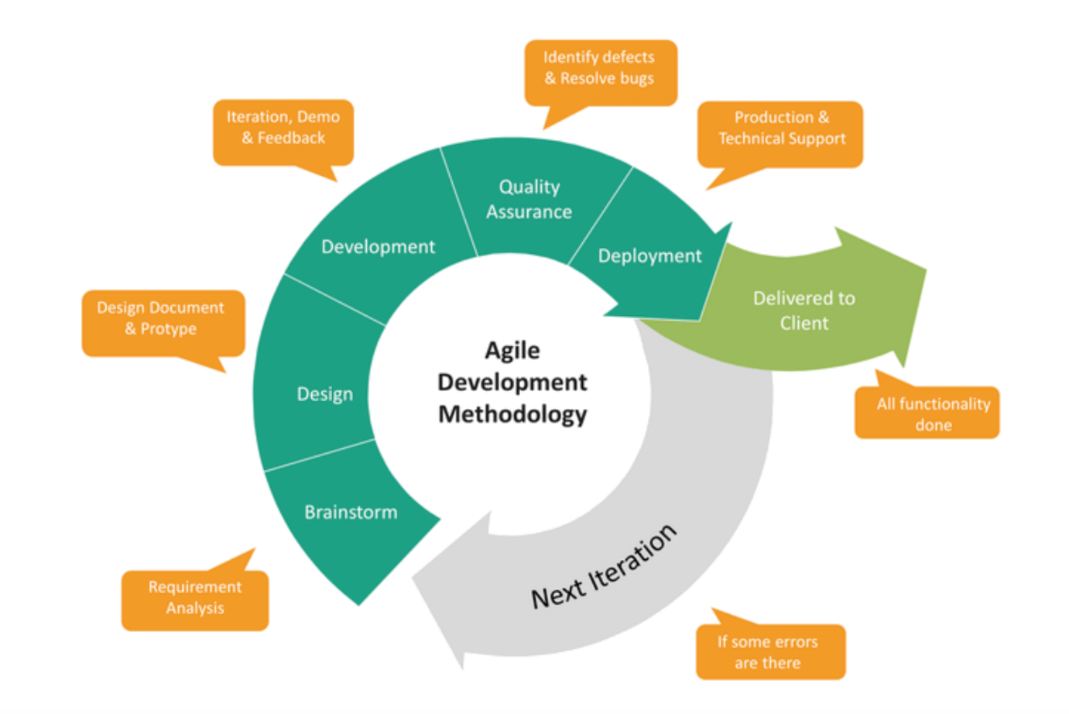

**Advantages of agile methodology**

* **Flexibility**: Agile allows for changes and adaptations throughout the project's lifecycle. As event planning can be dynamic with shifting requirements, Agile provides the flexibility to accommodate these changes efficiently.
* **Stakeholder Engagement**: Agile encourages regular communication with stakeholders, ensuring that their feedback is incorporated early and often. This ensures that the event planning platform aligns closely with user needs and expectations.
* **Incremental Delivery**: Agile promotes iterative development and incremental delivery. This means you can release features or modules of your event planning platform as they are completed, allowing users to benefit from functionalities sooner rather than later.
* **Quality Assurance**: With continuous testing integrated into the Agile process, any issues or bugs can be identified and addressed early on. This results in a higher quality product that meets user requirements and expectations.
* **Collaboration and Teamwork**: Agile emphasizes collaboration among team members, fostering a sense of ownership and accountability. This collaborative environment can lead to innovative solutions, efficient problem-solving, and a cohesive team working towards a common goal.
* **Customer Satisfaction**: By incorporating user feedback and delivering working functionalities in short iterations, Agile ensures that the final product meets customer needs and expectations more closely. This can lead to higher customer satisfaction and retention rates.
* **Risk Management**: Agile allows for early identification and mitigation of risks. Through regular reviews, retrospectives, and adjustments, potential challenges or roadblocks can be addressed proactively, ensuring smoother project progression.

Adopting the Agile methodology for your event planning platform can offer enhanced flexibility, stakeholder engagement, quality assurance, and team collaboration, ultimately leading to a more successful and user-centric product. (*The Benefits & Advantages of Agile | Wrike Agile Guide*, n.d.)

### Technology

Next, let's talk about the tools we use to create our platform. To create any software or web we need many tools like programming languages, coding software. Here I hope to talk about the tools we need to work like that.

* Programing language

In that case we are going to use three different languages. They are, HTML, CSS and Java Script. First of all, if we talk about HTML, HTML means Hypertext Markup Language. (Cox, 2021)

Hypertext Markup Language or HTML is the standard markup language for documents designed to be displayed in a web browser. Technologies such as Cascading Style Sheets (CSS) and scripting languages such as JavaScript can support it.

HTML is chosen as the most suitable programming language for our platform because it revolves around web pages. As highlighted by Tim Berners-Lee's research in April 2009 on wikipedia.org, HTML stands out as the ideal language for web applications. This informed decision to use HTML is backed by expert consensus in the field. We utilize HTML to establish the foundational template for our web platform. Subsequently, CSS is employed for customization purposes, tailoring the appearance to our specifications. To add functionality and interactivity, JavaScript is incorporated, complementing the design and layout. The use of CSS and JavaScript aligns with recognized research, ensuring seamless customization and enhanced user experience. Here's an illustration of the HTML page structure:

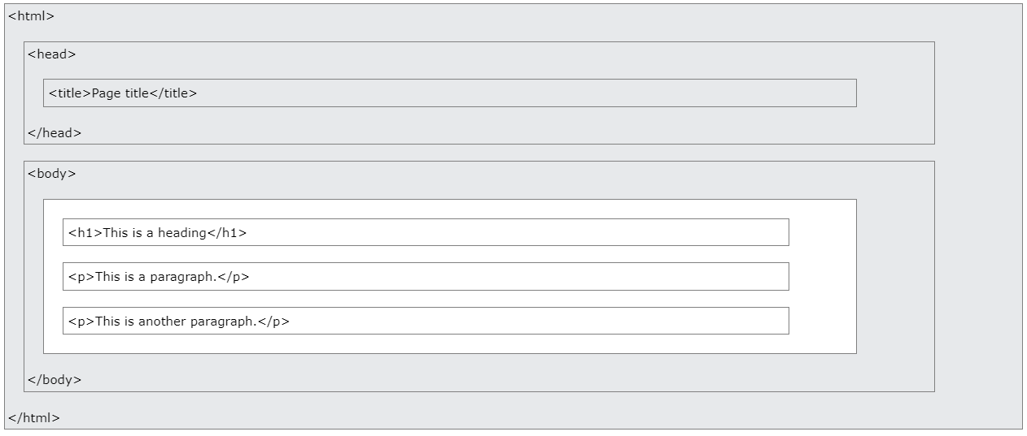

• NEXT JS

JavaScript framework Next.js streamlines React web development. It offers server-side rendering for faster page loads and SEO, static site generation for efficiency, and simple file-based routing. Developers can implement server less backend operations with built-in API routes. Hot module replacement and other stylistic solutions improve the developer experience in Next.js. It's a flexible, developer-friendly framework for modern web apps.

This website uses Next.js since it simplifies and speeds up development. React-based, it uses server-side rendering and automated code splitting to speed up page loading. The file-based routing architecture simplifies organization, and built-in API routes make backend development straightforward. Next.js enables many stylistic options, improving versatility, and its developer-friendly features, such hot module replacement, contribute to a seamless development experience. Overall, Next.js provides a powerful basis for constructing modern and performant websites.

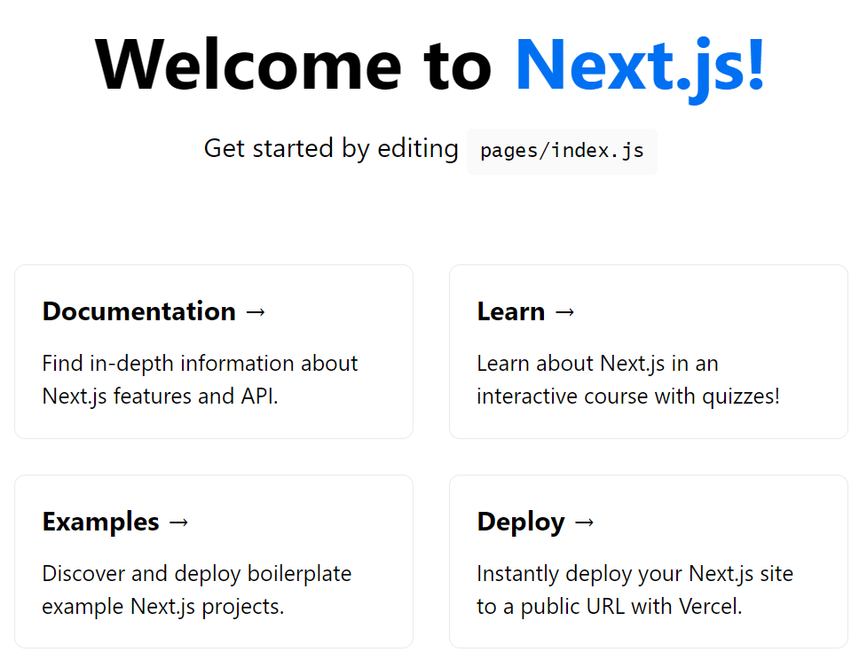

• NODE JS

Node.js is a server-side JavaScript runtime environment built on the V8 engine, enabling the development of scalable and fast network applications. It operates on an event-driven, non-blocking I/O model, efficiently handling multiple connections simultaneously. Widely used for building web servers and APIs, Node.js boasts a vast ecosystem of packages, making it a popular choice for server-side development projects.

Node.js is favored for backend development as it enables using JavaScript for both frontend and backend tasks. Its asynchronous, non-blocking design ensures efficient handling of multiple requests simultaneously, ensuring fast response times. With a rich module ecosystem, seamless integration of third-party tools, and robust community support, Node.js provides a flexible and scalable solution. Its cross-platform compatibility simplifies deployment, making it a popular choice for backend development, known for its simplicity, speed, and versatility. (Chaudhary, 2023)

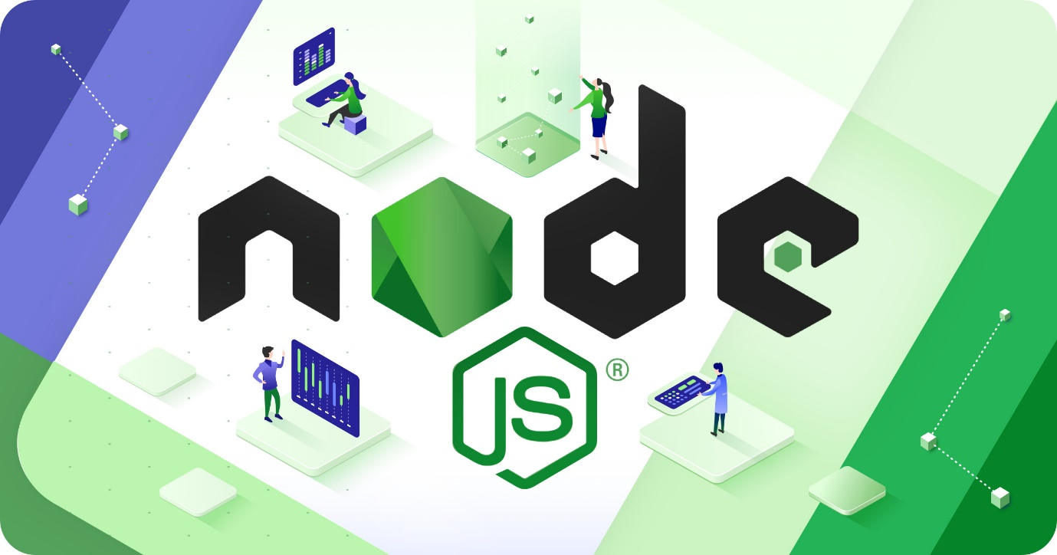

• EXPRESS JS

Express.js, a minimal and flexible web app framework for Node.js, streamlines building applications and APIs. It simplifies routing, HTTP request/response handling, and middleware management. With an opinionated structure, developers have the freedom to organize applications as they prefer. Widely utilized for server-side applications and APIs, Express offers simplicity, speed, and seamless integration with other Node.js modules. It's a lightweight yet powerful framework, facilitating the development of server-side JavaScript web applications.

Choose Express.js for the website, simplifying the construction of robust and scalable web applications. This minimalistic Node.js framework offers a straightforward approach to handling HTTP requests, routing, and middleware. Its opinionated design provides flexibility in structuring applications. Known for speed and efficiency, Express is ideal for server-side applications and APIs. With a large, active community, it provides abundant resources, plugins, and middleware options, streamlining development. In essence, Express.js empowers to build a reliable, efficient backend, allowing to focus on delivering a seamless user experience. (Ateam_admin, 2023)

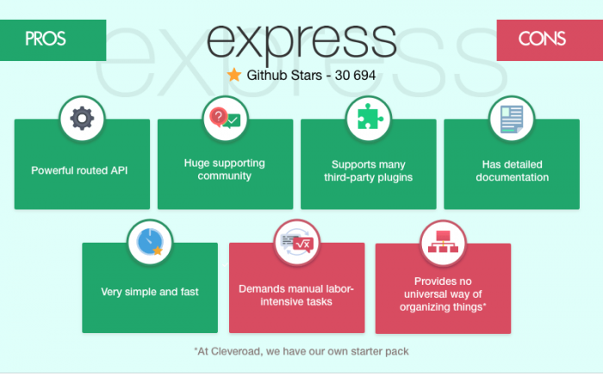

• MongoDB

MongoDB, an open-source NoSQL database, stores data in flexible JSON-like documents. It excels in managing evolving data structures, supports horizontal scaling via shading, and ensures high availability with features like replica sets. With a robust query language, indexing, and a strong community, MongoDB is widely used for applications prioritizing flexibility and scalability, such as content management systems and real-time analytics.

We choose MongoDB for our website due to its flexible and scalable data handling. Its document-oriented structure in a JSON-like format meets the evolving needs of our site. MongoDB scales horizontally with features like shading, ensuring effective management of growing data and traffic. Its dynamic schema and support for diverse data types suit our website's requirements. With an active community and robust ecosystem, MongoDB enables efficient data management and retrieval for our site.

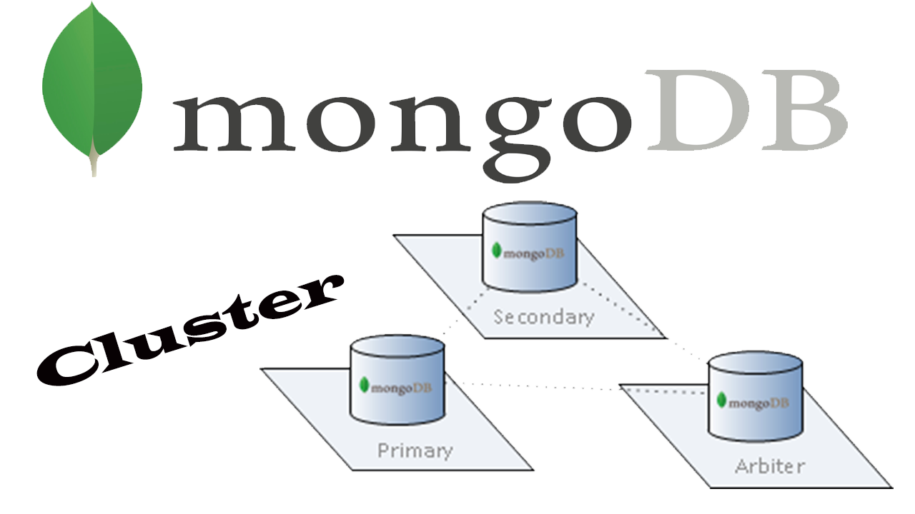

### Gantt chart

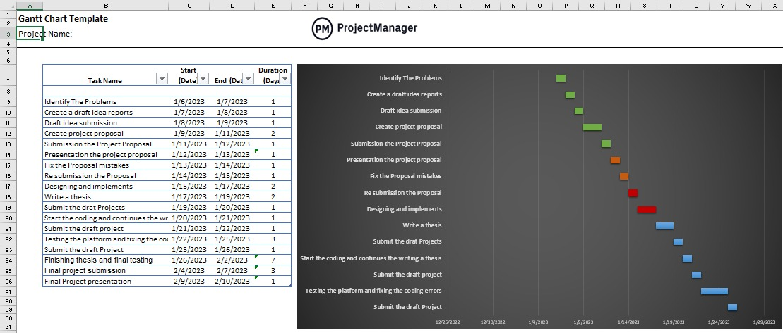

### Risks

Identifying potential risks is crucial for any project to ensure its successful execution. Here are some risks associated with the above-mentioned event planning platform:

* **Security Concerns**: Given that the platform involves online transactions, user data storage, and payment processing, security breaches, cyber-attacks, or data leaks could pose significant risks. Ensuring robust cybersecurity measures, encryption protocols, and compliance with data protection regulations is essential to mitigate these risks.
* **Technical Challenges**: Utilizing multiple programming languages, tools, and software solutions may lead to technical complexities, compatibility issues, or integration challenges. Ensuring consistent updates, maintenance, and testing across different components of the platform is crucial to avoid technical disruptions or system failures.
* **Vendor Reliability**: Dependence on various vendors, including venue providers, service providers, payment gateway providers, and technology partners, exposes the project to risks associated with vendor reliability, performance inconsistencies, contractual disputes, or service disruptions. Establishing clear agreements, monitoring vendor performance, and having contingency plans in place are essential to mitigate these risks.
* **User Adoption and Satisfaction**: Ensuring user adoption, engagement, and satisfaction with the platform's features, functionalities, and user experience is critical for its success. Risks such as low user adoption rates, negative feedback, or dissatisfaction with platform offerings could impact its popularity, reputation, and success in the market.
* **Regulatory and Compliance Risks**: Operating in the event planning industry may expose the platform to various regulatory requirements, licensing, permits, or compliance obligations. Risks associated with non-compliance, regulatory changes, or legal challenges could result in penalties, reputational damage, or operational disruptions.
* **Market Competition**: The event planning industry is highly competitive, with various established platforms, vendors, and service providers catering to diverse consumer needs. Risks such as market saturation, competitive pressures, or evolving consumer preferences could impact the platform's market share, growth prospects, or revenue generation.
* **Financial Risks**: Managing project costs, budget overruns, funding constraints, or financial uncertainties could pose risks to the platform's development, implementation, or sustainability. Ensuring effective financial planning, resource allocation, and budget management are essential to mitigate these risks.

The event planning platform faces risks related to security, technical challenges, vendor reliability, user adoption, regulatory compliance, market competition, and financial management. Implementing proactive risk management strategies, continuous monitoring, and timely mitigation measures are essential to address these risks and ensure the platform's success.

# Chapter 02

## Feasibility study report